

MAIRA EMAAN NASIR  
2430-0153  
 BSCS

PROGRAMMING FUNDAMENTALS  
LAB TASK NO 1

QUESTION: 01

SOLUTION:

CODE:

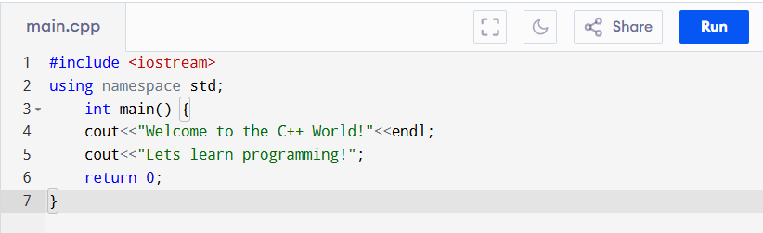

OUTPUT:

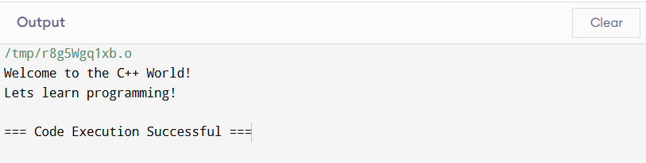

QUESTION: 02

SOLUTION:

CODE:

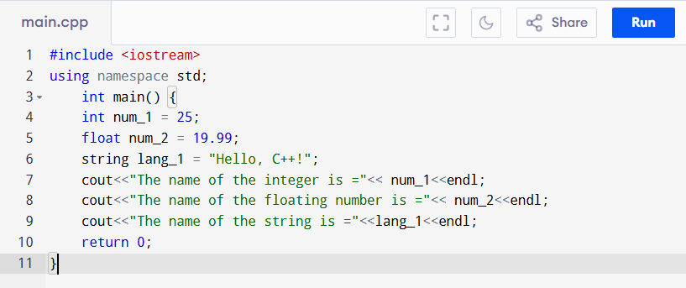

OUTPUT:

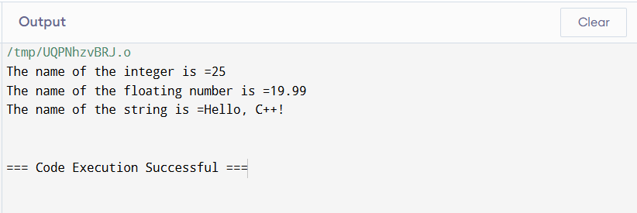

QUESTION: 03

SOLUTION

CODE:

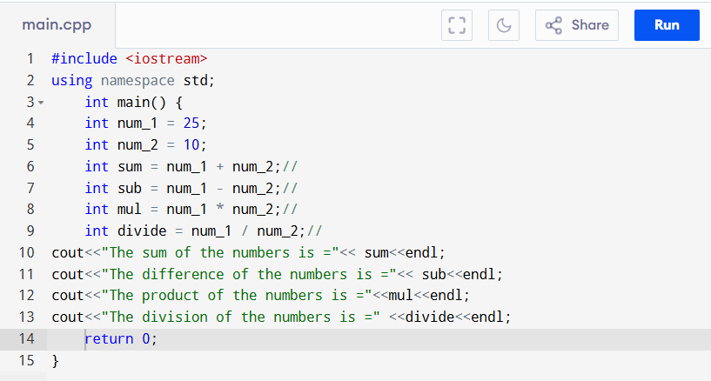

OUTPUT:

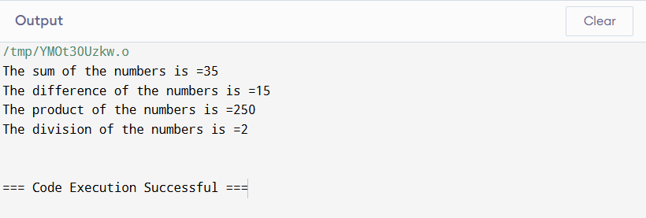

QUESTION: 04

SOLUTION

CODE:

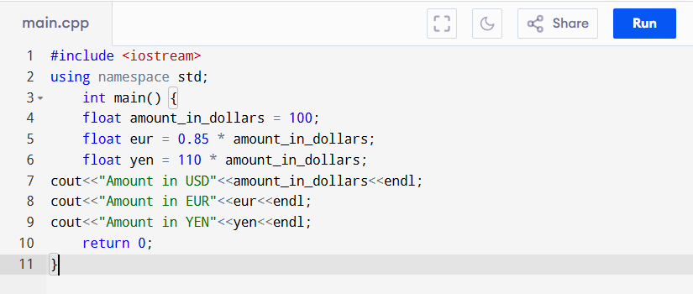

OUTPUT:

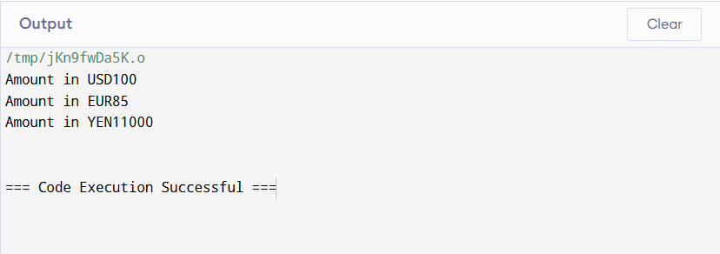

QUESTION: 05

SOLUTION

CODE:

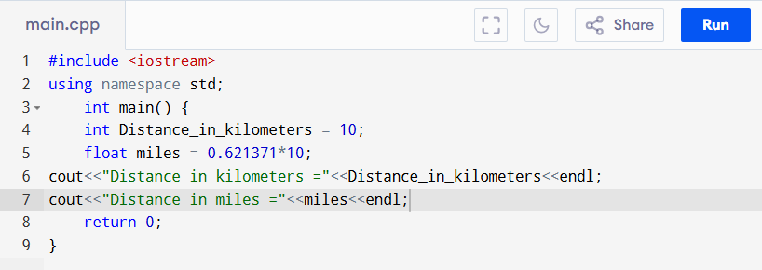

OUTPUT:

